The main page of docker and how it looks,

After creating your docker image type “doker image list” will give you the image list that is available on the system and you type” docker run ‘image_name’”

It will run the image and what your program does it will be displayed on the terminal as shown below.

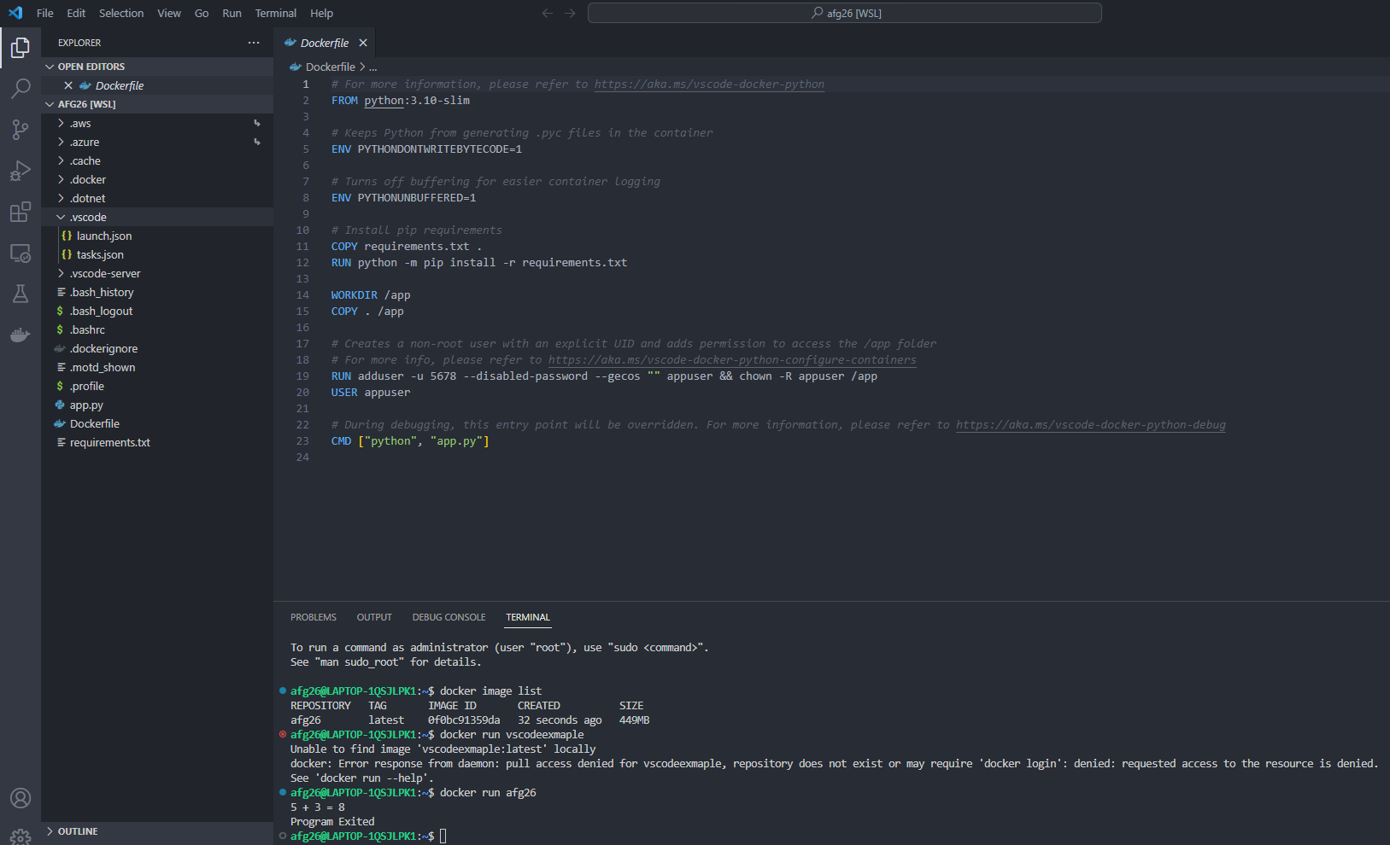

How debugging works in docker: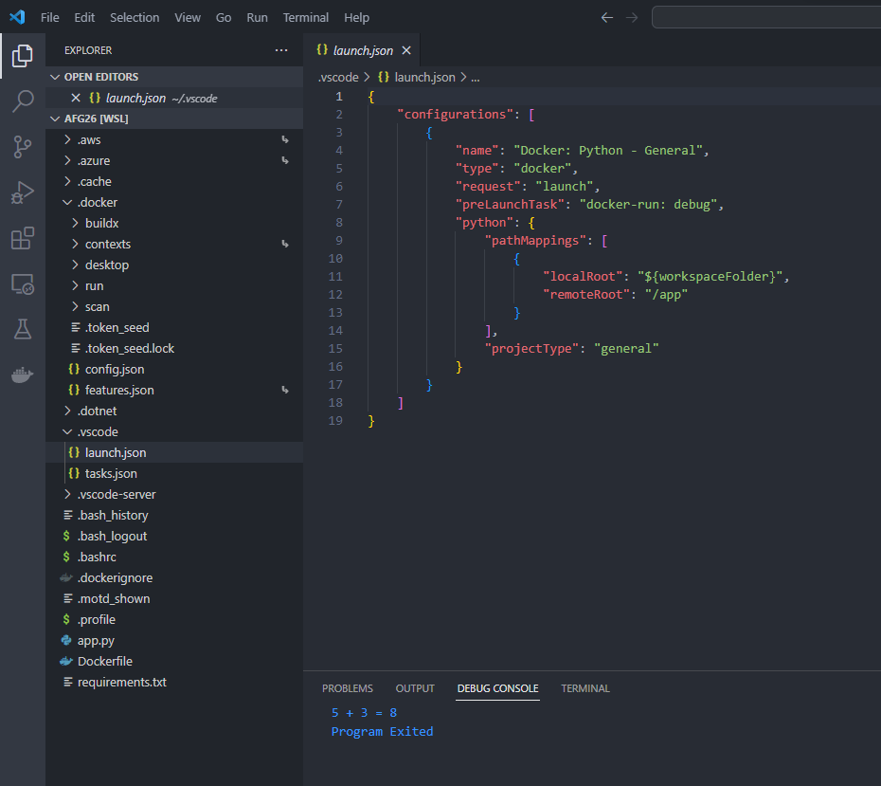

Some file in the folder vscode by the name of task.json and launch.json is created automatically and it shows how the debugging works.

